4.6.2 Triple Integrals in Spherical Coordinates Worksheet

- Change the following points from rectangular coordinates to spherical coordinates.

- True or False: Every point in can be uniquely represented in spherical coordinates.

- Describe in words the surface who equation is given.

- For each of the given integrals, label the box below the picture of the corresponding region of integration in spherical coordinates.
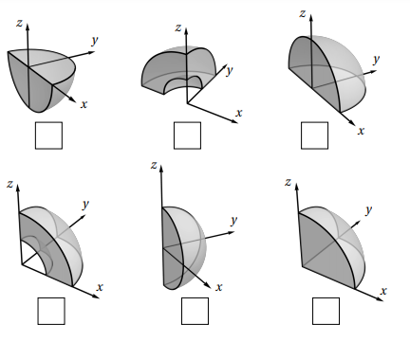

- For each of the given integrals, label the box below the picture of the corresponding region of integration in spherical coordinates.
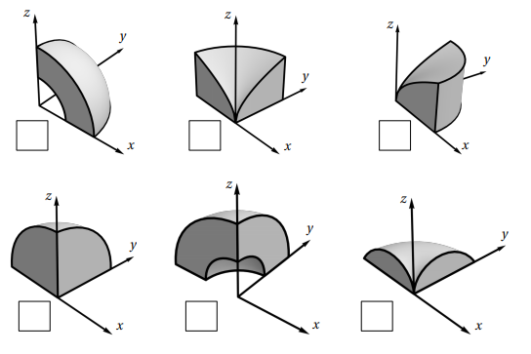

- The triple integral gives the volume of: (select which answer is correct)
- half a sphere of radius 2.
- One eighth of a sphere of radius 2.
- One quarter of a sphere of radius 2.

- Sketch the solid whose volume is given by the integral and then evaluate the integral.

- Setup, but do not evaluate , where E is the solid hemisphere .

- Evaluate , where E lies between the spheres and .

- Evaluate , where E is the solid hemisphere the spheres .

- Evaluate , where E is the portion of the unit ball that lies in the first octant.

- Evaluate , where E lies between the spheres and and above the cone .

- Find the volume of the part of the ball that lies between the cones and .

- Convert each of the following integrals to cylindrical coordinates.

